PROJECT DESCRIPTION - AS 91893 Digital Media Outcome
Level 2 Digital Media · Student Documentation Template (Any project)
Use for any digital media outcome (web page/app UI, interactive media, etc.). Hub options include inventory tracker, finance learning tool, job board, or your own brief.
Student name | Oscar Berryman
Class / year | Year 12
Project title | Investment Decision Journal
Media type / stack | HTML, CSS, and Java
Teacher brief approved? | ☐ Yes
Date started | ________________________________

The problem
Who are the end users?
- The end users are people who are interested in investing, and want a clear, easy way to track their thesis across different stocks and investments.
What problem does the digital media outcome solve?
- The problem that the digital media outcome solves is the issue of people forgetting to review their theses on stocks as the market changes, this can lead to people not understanding what they hold, or becoming confused when their portfolio doesn’t represent their intentions.
What should users see/do when it works?
- An app that compiles/aggregates news articles, data and analyst ratings for stocks.
- Users can add their current holdings, and enter and update their thesis for stocks.
- They can add their bear and bull case.
- They can add their confidence level.
- They can add their predictions for future price levels and business data.
- Users set a date for review on their thesis that triggers a notification to help them stay consistent in their views.
- They can write a reflection / update holdings when the alert triggers, which can help them learn how to analyse better In the future.
- Review feature could also function as getting users to review their watchlist holdings, to see if the right time to buy for them has come yet.
- Clean portfolio dashboard with sector exposure by percentage
MY wireframe mock-up:

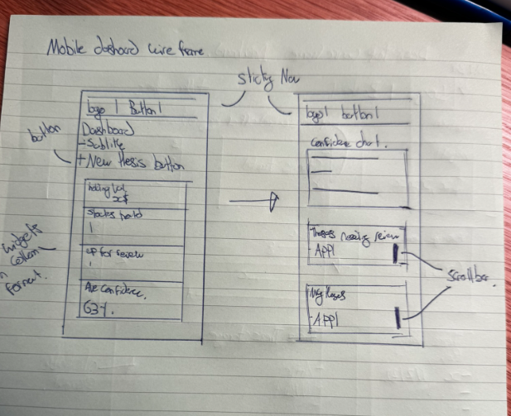
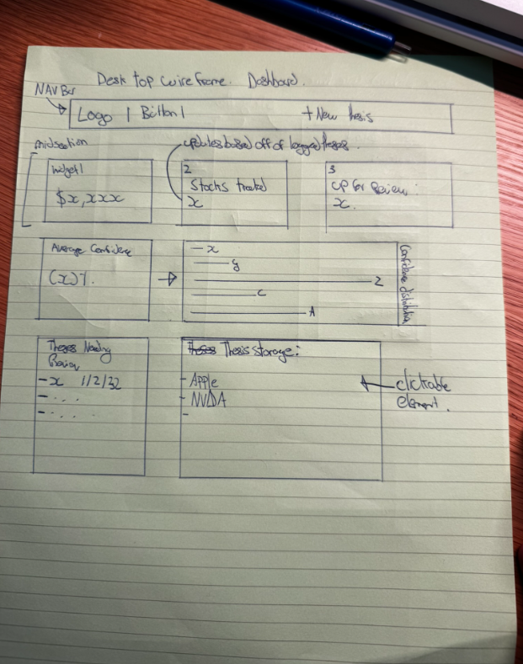

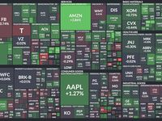
Planning :
Homepage that looks something like this
Review Urgency Heatmap
Tile size = portfolio weighting
Color = days until next review
- Green = recently reviewed

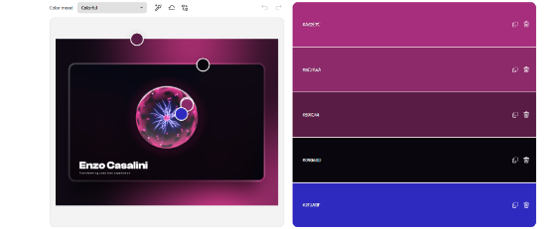
- Yellow = review due soon
- Red = overdue review
Color Palette Generator From Image | Adobe Express​
Enzo Casalini - Creative Developer Portfolio
Create a Palette - Coolors

Advanced techniques
Example advanced technique | What it might look like | Where in my project
CSS custom properties / themes | :root tokens for colour, space, type | :root {  --brown: #7B5132;  --apricot: #D98452;  --beige: #FFC67E;  --off-white: #FFEEC7;  }  I use CSS custom properties in the :root selector to define reusable colours and other design values. These variables are used throughout the interface to maintain a consistent visual style and make the design easier to modify.  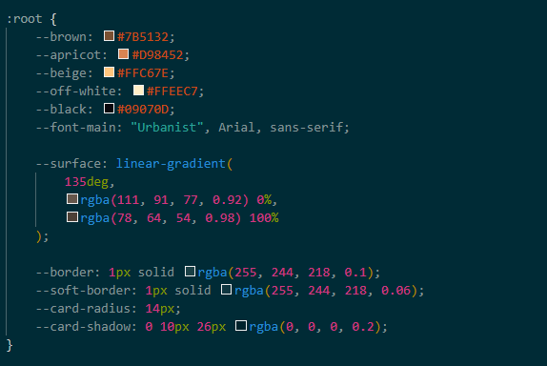  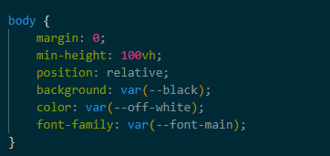
Responsive layout system | Mobile-first flex/grid + breakpoints  I will use flexbox/ grid and media queries to make the interface adapt to the screen size. | I use Flexbox/Grid and media queries to create a responsive interface that adapts to different screen sizes. This allows the dashboard, navigation and content cards to rearrange appropriately on mobile and larger screens, making the outcome usable across different devices.  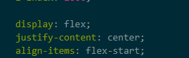
Reusable UI pattern | Shared card/component classes or partials
Data-driven content | JSON/CSV mapped to visible UI | Json and localstorage to save users thesis parts. The data will be accessible in the users ‘saved theses’ box on the home page of the dashboard.  When clicked on in the saved theses section, saved thesis data populates a form showing all the information that was entered previously, organized neatly.  
Scripts / interactivity | Custom JS for filters, tabs, states
Third-party library | Charts, icons, UI kit used with understanding
Asset pipeline / optimisation | Compressed images, sprites, consistent paths

Gaps I still need to add:

My ≥2 techniques for assessment:
- I am going to use a JSON file to track users investment thesis and options. I have chosen this because it allows me to record a lot of data, for different users and populate more than one html file with this data. I also like how easy it is to save things to it from my previous assessment.
- Responsive system layout using flexbox / grid to ensure my interface can be used on mobile devices and larger screens. This makes it more accessible to a greater amount of users, and especially casual investors which is most people.

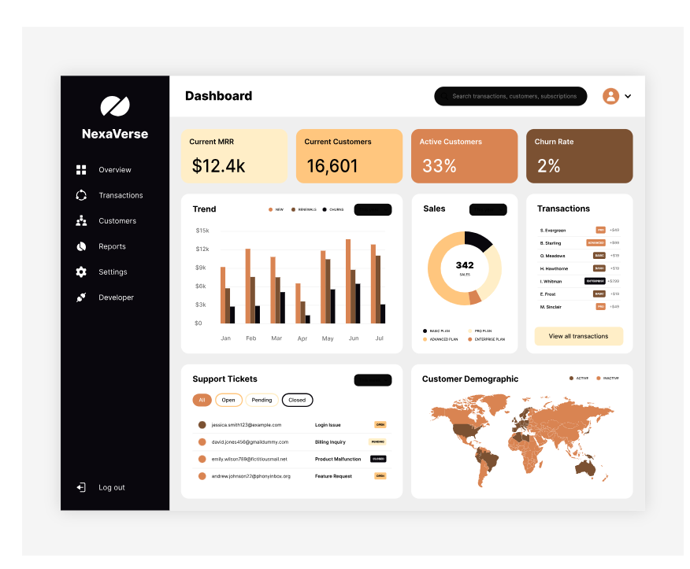
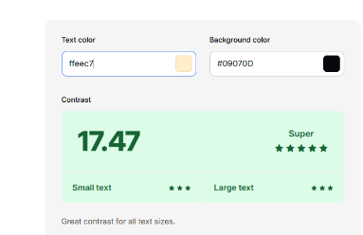
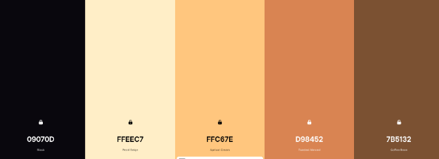
Colour palette testing:

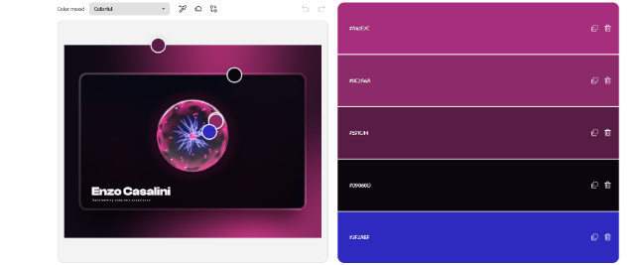
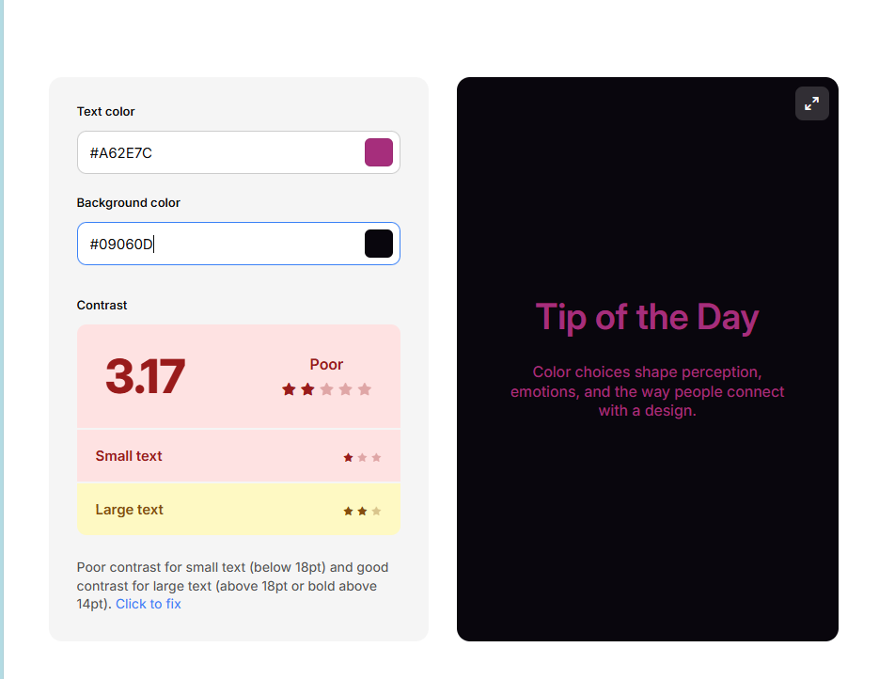

The obvious choice for my colour palette is the off-white-brown one. My aesthetic trailing already reported that users like the off-white-brown colour palette the best, and also think that it looks the most suitable for the topic of my website. The colour palette needs to be mature, because people may be using my journal to decide where thousands of their own dollars go, the pink would make it feel too game-afied. The contrast on the pink colour palette is also much worse than the off-white-brown one which is important because users need to be able to clearly read my website.

Font testing:
Specification:
I want a font that looks clean, and minimalistic. Investment decisions should be about precision so a clear font will help make the user experience feel precise and calibrated.
Selection Embed Code - Google Fonts
Urbanist:
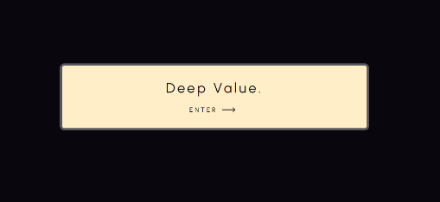
Sensation:
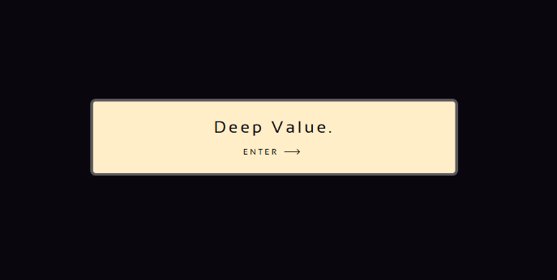
I chose to go with urbanist because I feel like the letter design feels more modern, sensation looks closer to a type writer. I also think that it looks a bit more rigid, the sensation letters are very square and that’s not what I want for a welcoming page. More rounded fonts make the user experience more inviting.

My selection:
- I chose the urbanist font because my aesthetic feedback reported that users liked it the most. I also like it too.

Implications

Implication | Why it matters for my user | How I addresseed it (Merit+) | Evidence
Accessibility | Because my app is designed for all investors it’s important that people with disabilities can use it. With increasing amounts of people interested in the stock market I think there will be a increasing amount of disabled people looking for an inclusive interface which allows them to invest like any other person, so making my interface accessible is a great way to capture this market.  feedback suggesting a screen resizer from Nikhil: | I used high colour contrast, appropriate headings and scalable text to make the interface easier to use with screen readers and magnification.  See implementation log for my text resizer and accessibility menu in my work log on the 26th of august. |   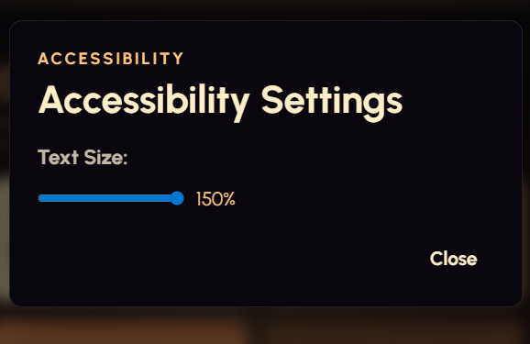  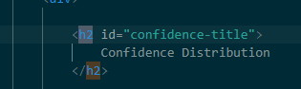  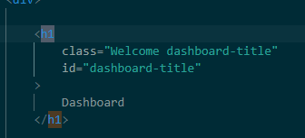  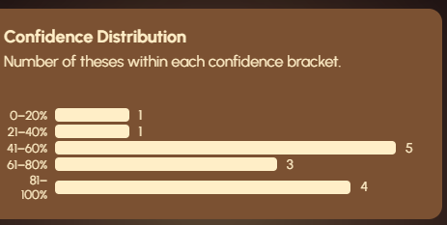
Privacy / IP / ethics | Because my application stores users’ investment decisions, including information about trades and financial data, it is important that their privacy is managed in a way that does not expose them to any unknown risks. | I addressed this by displaying my disclaimer on top of the thesisentryform.html with a blurred background around it forcing them to make a decision, and explaining that their data will be stored locally if they choose to continue.  I also provide information about their data collection and say that they should not enter any personal data they do not wish to share as this may be visible to other users using the same device. | 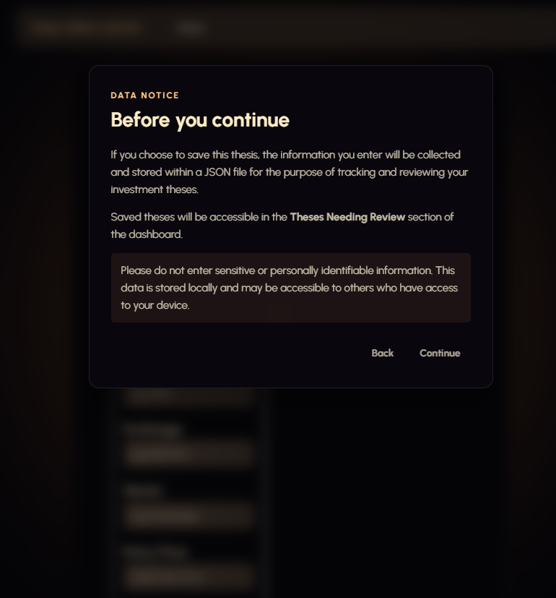
Aesthetics / functionality | My users need to be able to make quick, informed investment decisions. It also needs to be easy to understand that information, so the visual design and functionality of the interface need to be designed in a way that makes that information easy to access. Poor layout or an inconsistent design could make my interface difficult to use. | I used CSS flexbox, media queries, consistent styling and a visual hierarchy to create an interface that adapts to different screen sizes. | 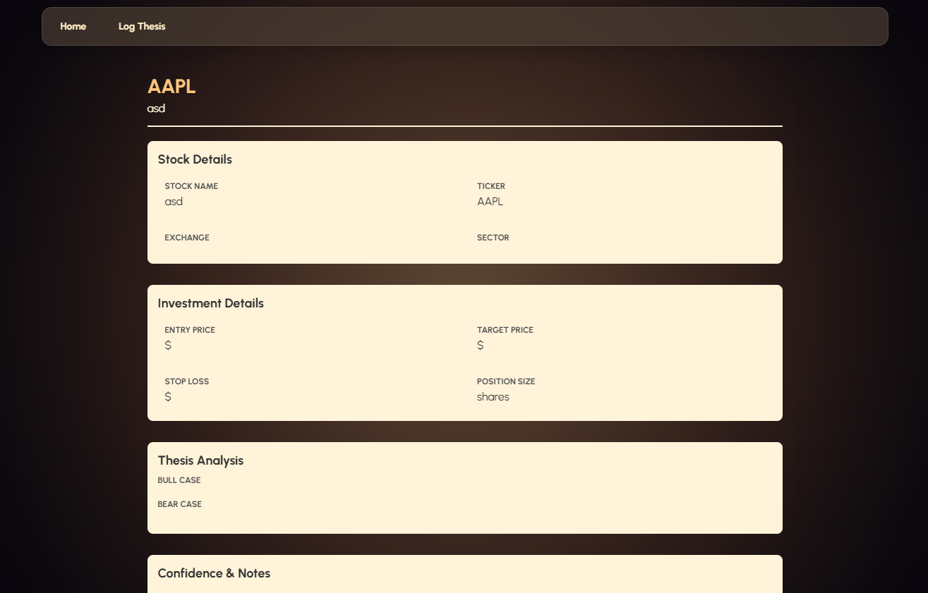  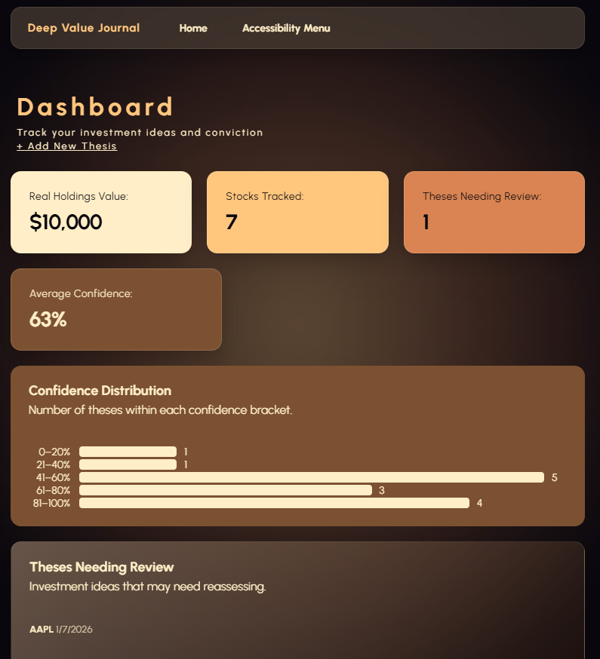  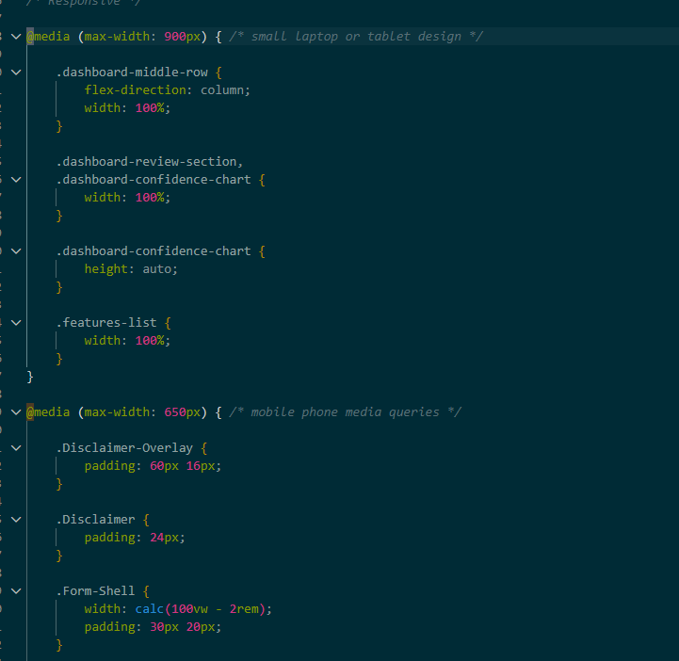

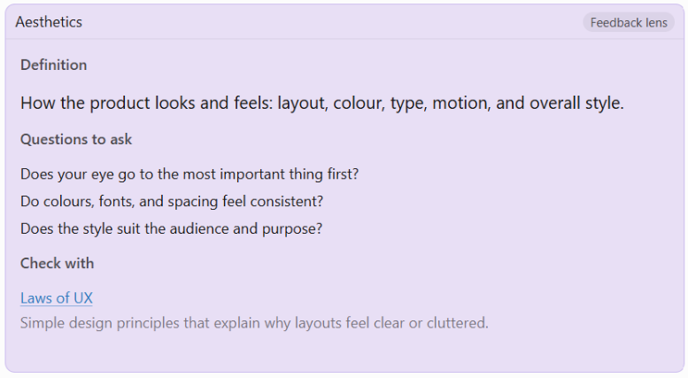
Early stage Feedback - Aesthetics

Name: Nikhil
Does your eye go to the most important thing first?
My eye was attracted to the glowing button first on the landing page, so yes I think so, on the home page they are drawn to colourful widgets first, which is good.
Do colours, fonts, and spacing feel consistent?
I think that it has a nice colour scheme. And there are some nice aminations that you have added from the nicegui. I like the urbanist font the most out of the two options.
Does the style suit the audience and purpose?
The colour scheme feels very mature which is perfect for an investment journal platform.
My nextsteps for you:
I think the next step is adding a enter button or making it so you can enter your name by clicking the enter button on your keyboard. I also feel that you could make the writing a little bit bigger because there is so much space that isn’t really doing anything . I also think that you should add a font resizer tool and an accessibility menu. While your small font is visually appealing, those with poor eyesight may not be able to read the text, so adding a resizer would make the interface more user friendly for a wider variety of users.

Changes made based on this feedback:
- Removed the name entry input + button because I felt like it didn’t serve a purpose.

Name: Kevin – Year 11
My focus point – peer feedback – 11/08/2026
Does your eye go to the most important thing first?
It’s very neat, great lighting, cool halo button design, Great title, Pressing the button gives off full highlights. Cool Loading screen 10/10. Very neat so eyes don’t hurt/no distractions. So yes it does go to the most important thing.
Do colours, fonts, and spacing feel consistent?
Yes everything is spread out, it’s very consistent, all the buttons are smooth and working. Colours really work well together, the pumpkin orange colour gives of a luxury vibe.
Does the style suit the audience and purpose?
Yes as this website is designed towards people who like analysis and investing.
My nextsteps for you:
Put some more contents on the front of the page. I like the urbanist font the most out of the two options.

Name: Jake – Year 11
My nextsteps for you:
Add a stock searcher, you can search by ticker
Add a graph for each stock,
Keep title color the same
Sensation font is better

Name: Nikhil - Aesthetic and features feedback: 1/08/26
What my interface currently looks like:
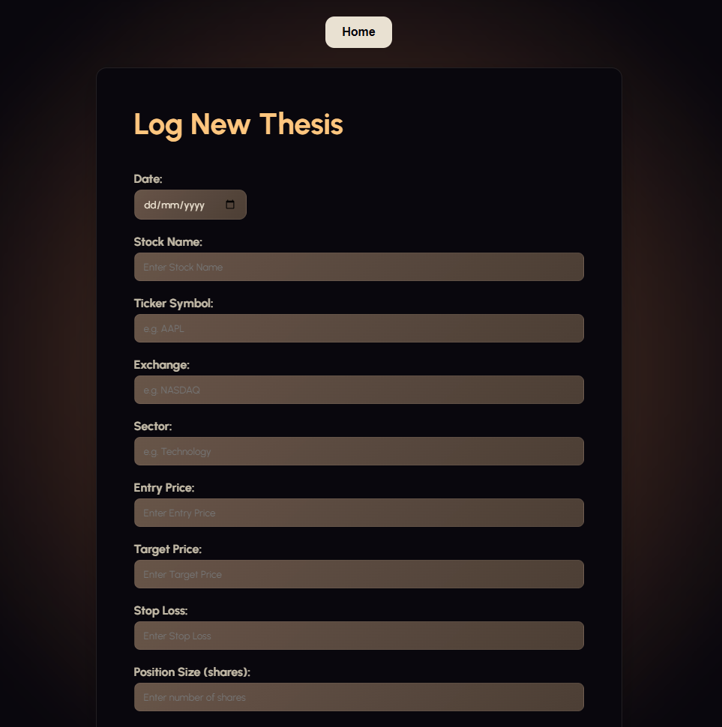
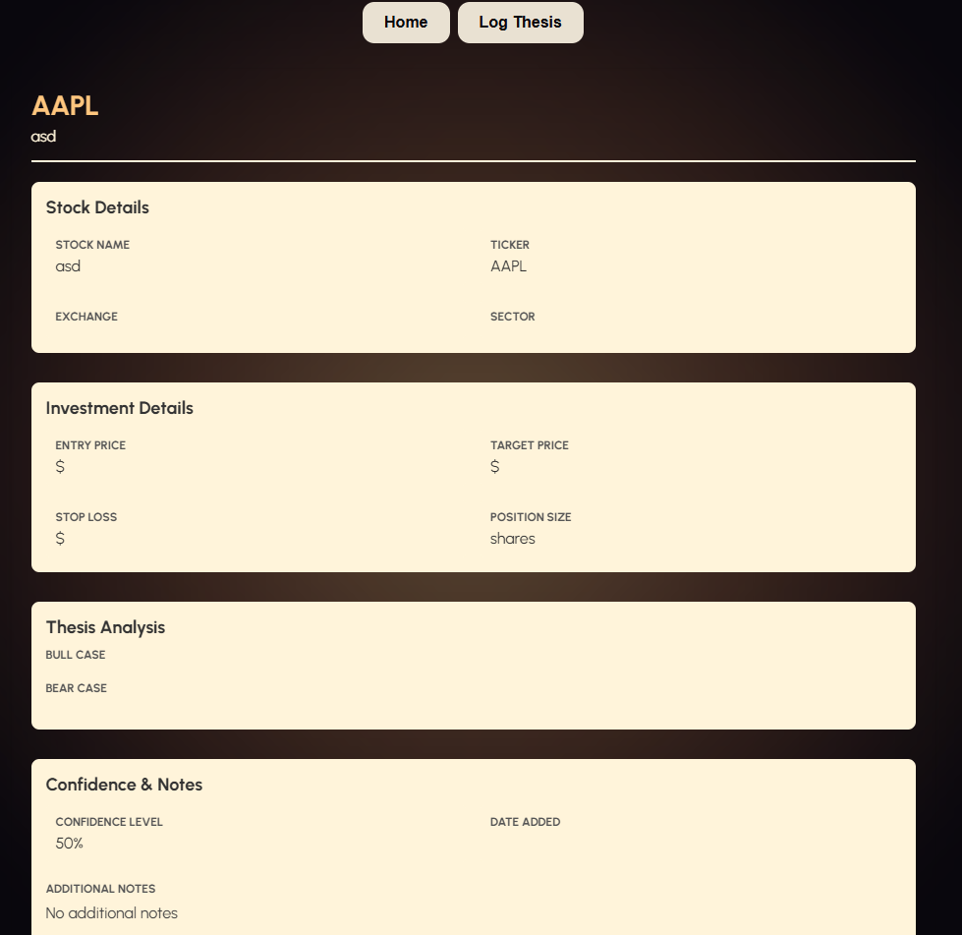
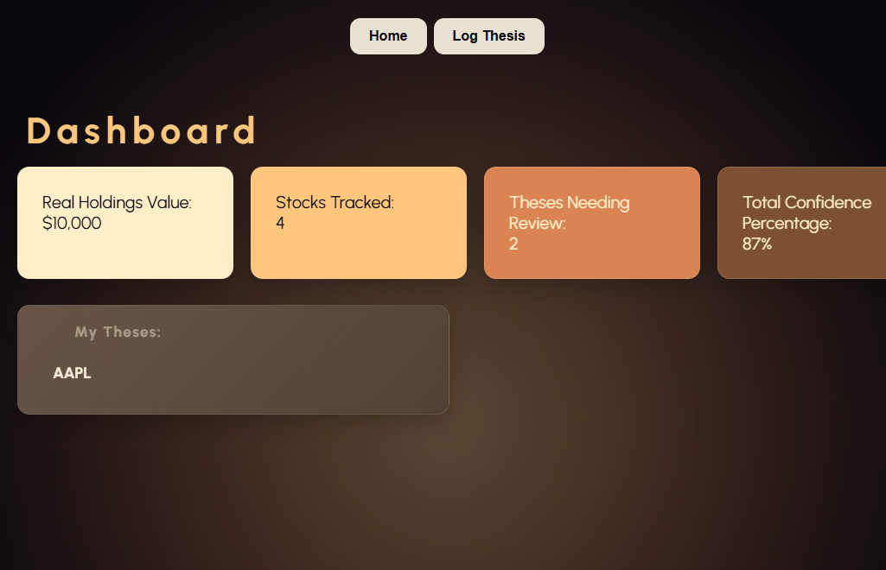

I think that it looks good, and that the structure and flex box are all working good when the dimensions get smaller. I do wonder whether a lot of text is going to contrast well with the background and the colour of text you have chosen. I think you should either change the colours or make an accessibility button that makes it so you can change the contrast. On the log page you could change the colour of text in the input box as it is quite hard to read.
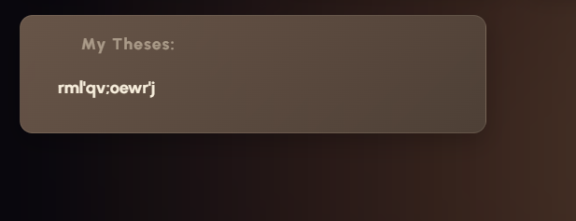

I think that you could do some error prevention because right now you can spam the keyboard and it accepts it. I also think the navigation bar looks clunky, and the add new thesis button is already above the navigation widgets. I think you should remove the log thesis button at the top.

Name: Nikhil - Aesthetic and features feedback: 31/08/26
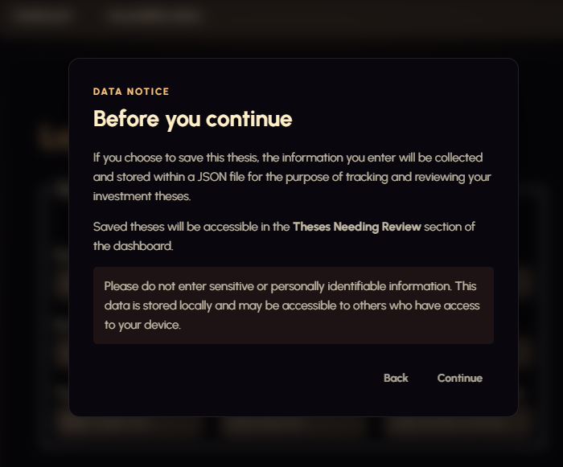
I think that the contrast between the disclaimer background and the text is too little. Its black and grey. It is important to have high contrast on the disclaimer because is an important message about privacy, so legibility matters.

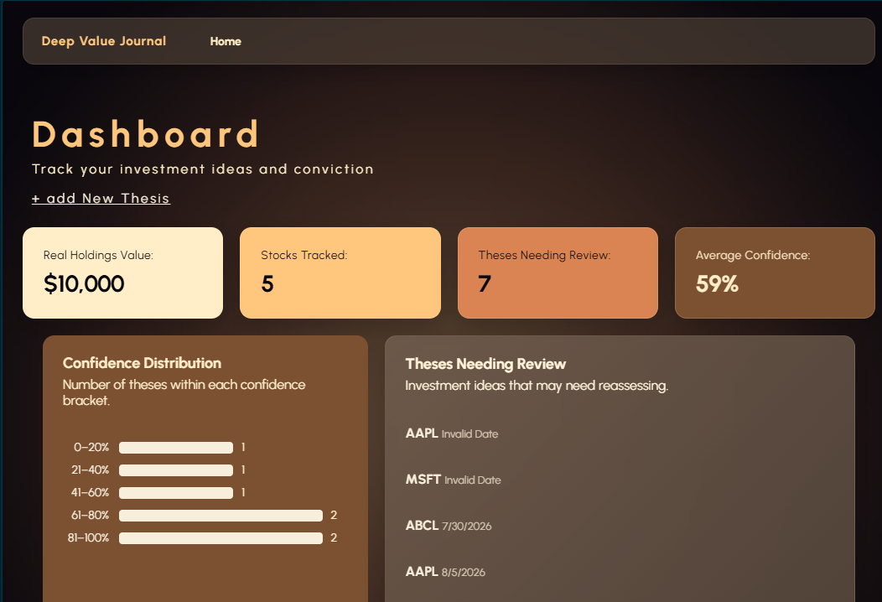
Changes Made based on feedback:
- I have removed the log new thesis in the navigation bar. + restyled it to have better contrast, and look better.


- Changed the colour of the text in the input boxes on my form – see aesthetic optimizations section (click here)
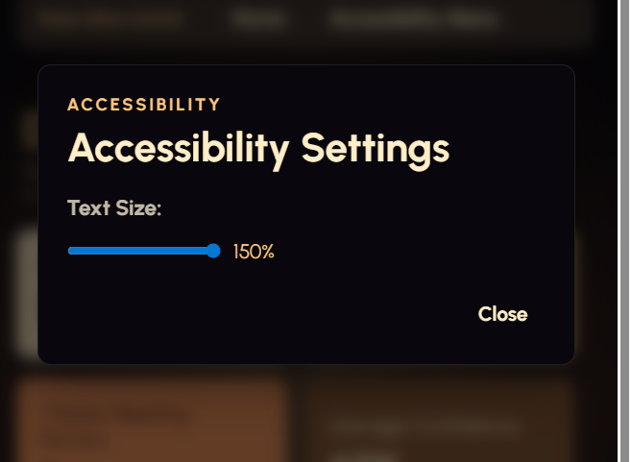
- Added a text resizer. See work log on the 26th for implementation evidence
- Tested for contrast on my disclaimer between the <p> text and the background. Updated it to be higher contrast by changing the grey to the off-white colour present throughout my interface.

Two methods of project management for planning:
- https://www.figma.com/make/DsBcsbG96y2TW2J4hgVnID/Stock-research-app?t=hVCeLNTpkXmkmuug-1
- Comp Sci | Trello
- + my github repository OSCARB123123/Standard-2 which helps me to track version history
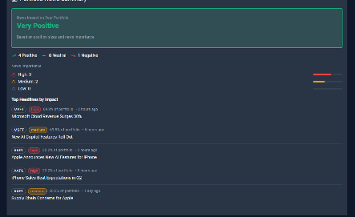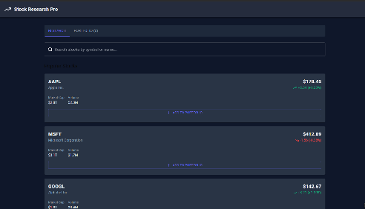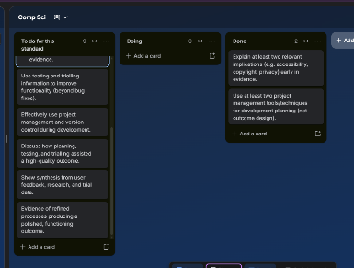
Required component breakdown:
- Interesting animation for the background
- Ability to input stock holdings by value and share size
- A wide variety of stocks to choose from
- Ability to input users own thesis, and record it
- Ability to send users notifications and set review dates for their thesis

